|  |  |
| --- | --- |
| Date | 26 October 2022 |
| Team ID | PNT2022TMID15139 |
| Project Name | Smart Farmer - IoT Enabled Smart Farming Application |

**CREATE AN ACCOUNT IN FAST2SMS DASHBOARD:**

**Step 1: Search fast2sms in google**

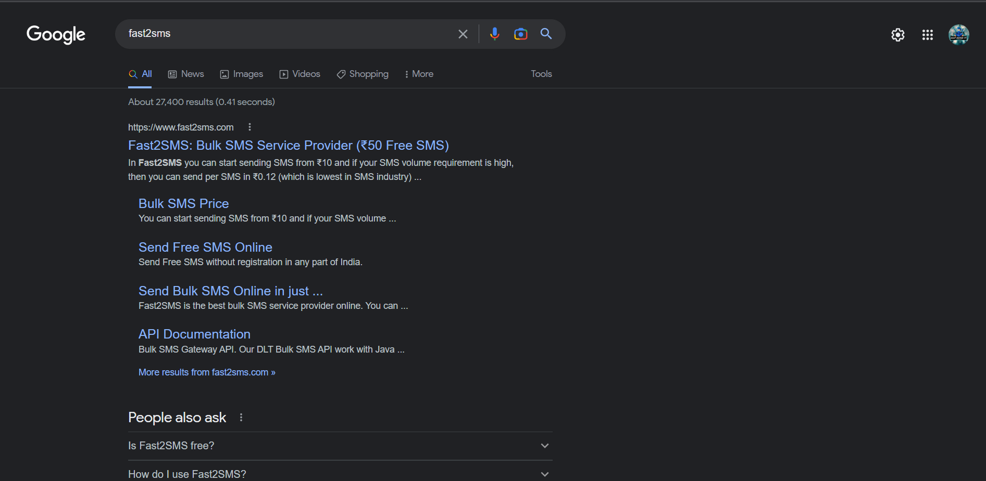

**Step 2: Signup in fast2sms using your personal information**

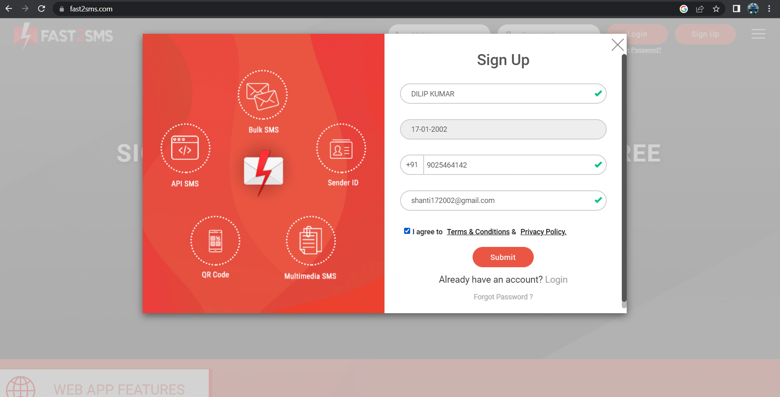

**Step 3: Select Dev API**

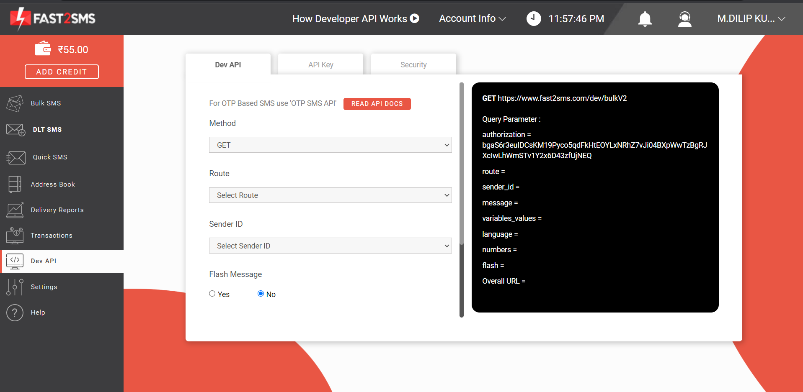

**Step 4: Select your preferrable method and route to send messages**

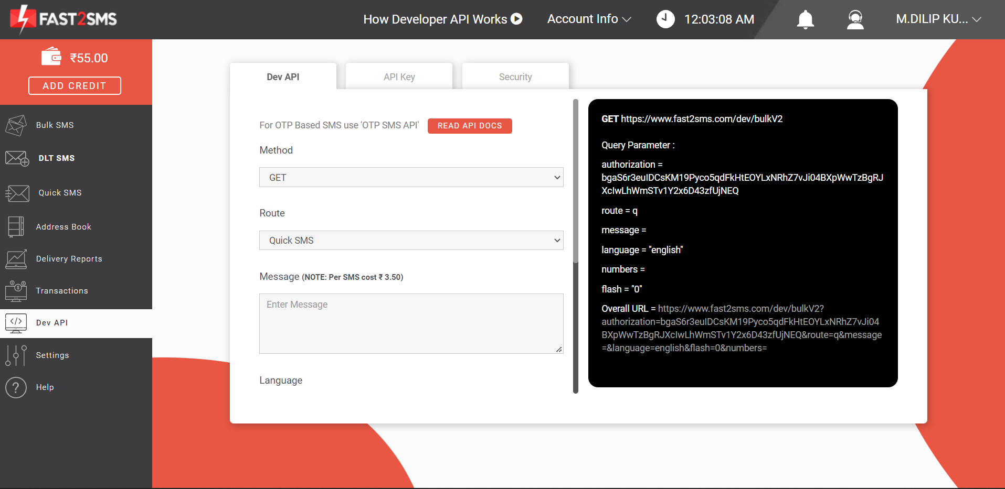

**Step 5: Type Mobile Number and Message and send the message**

